Example how to pack and unpack SQL Profiles via OEM

1. Go to OEM select particular database: HEPYPRD

Log under your A/N oracle account

Find sqlid with SQL Profile you want to save (pack)

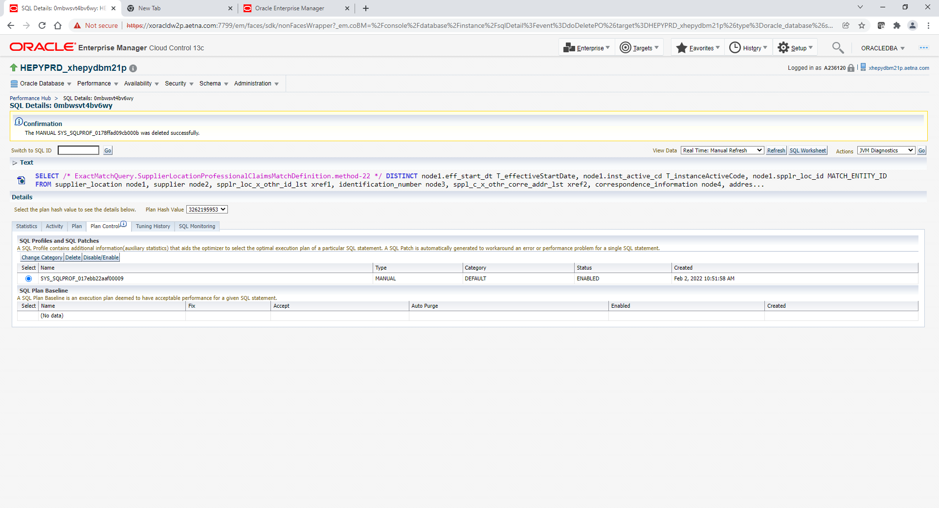

Make note like Profile name and SQLID tag

SYS_SQLPROF_017ebb22aaf00009

ExactMatchQuery.SupplierLocationProfessionalClaimsMatchDefinition.method-22

2. Go to Performance->SQL->SQL Plan Control

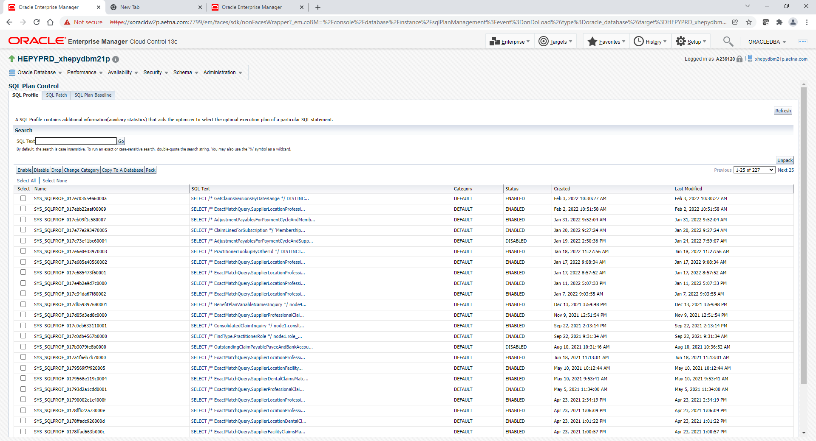

SQL Text search box specify following: %ExactMatchQuery.SupplierLocationProfessionalClaimsMatchDefinition.method-22%

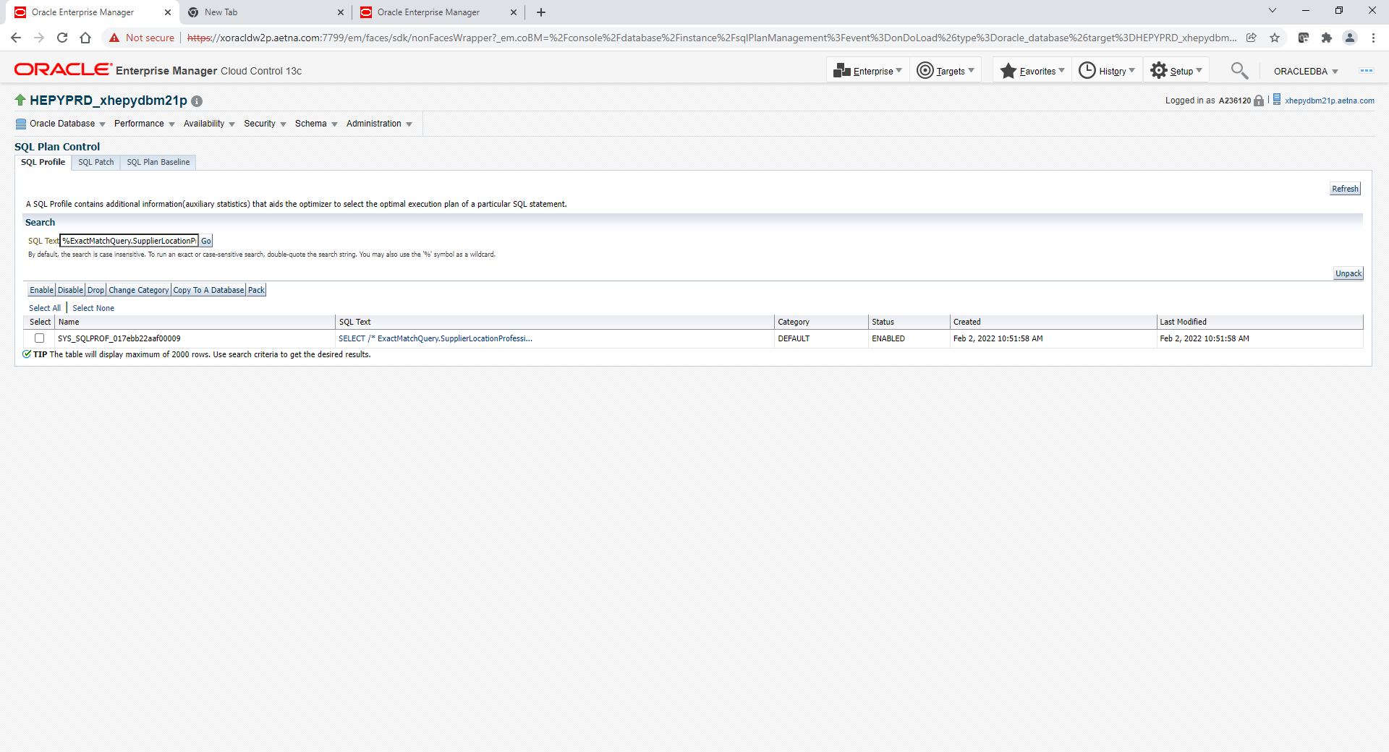

4. Select SQL Profile and click Pack.

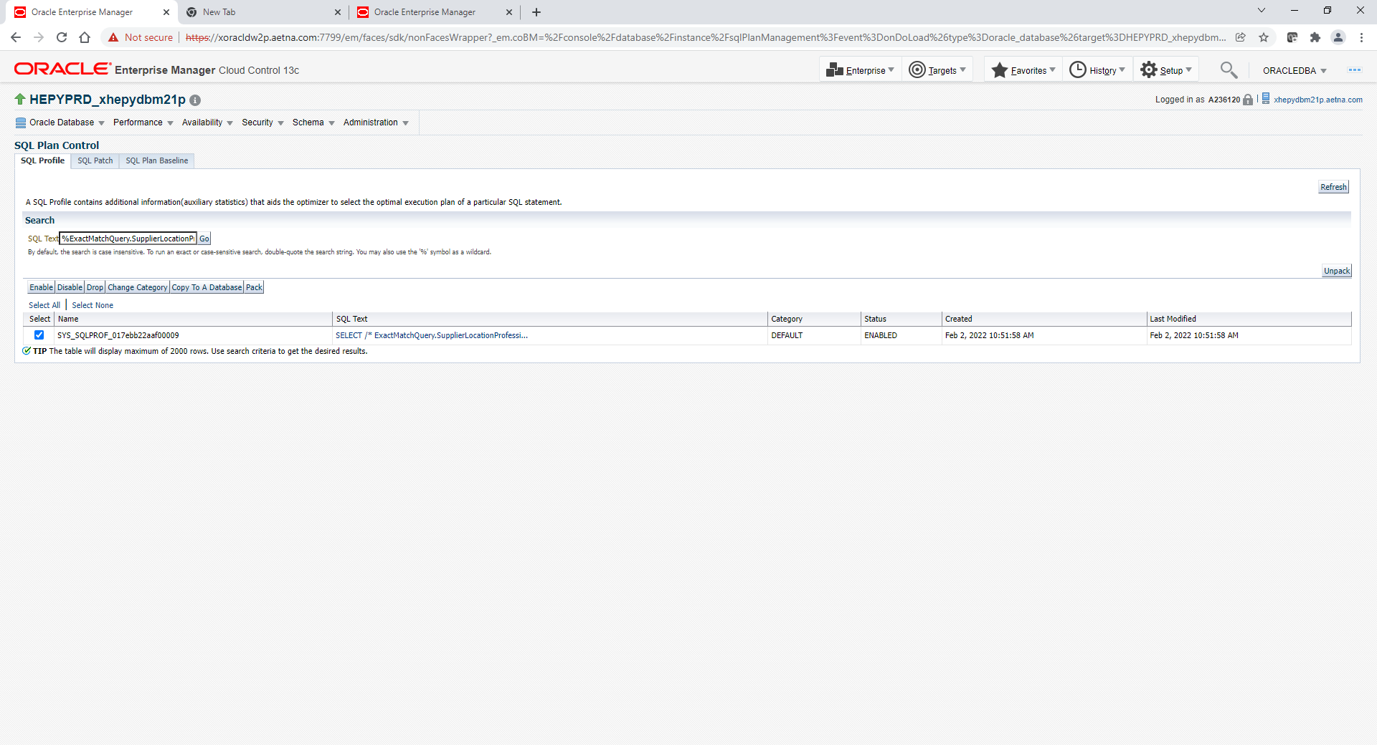

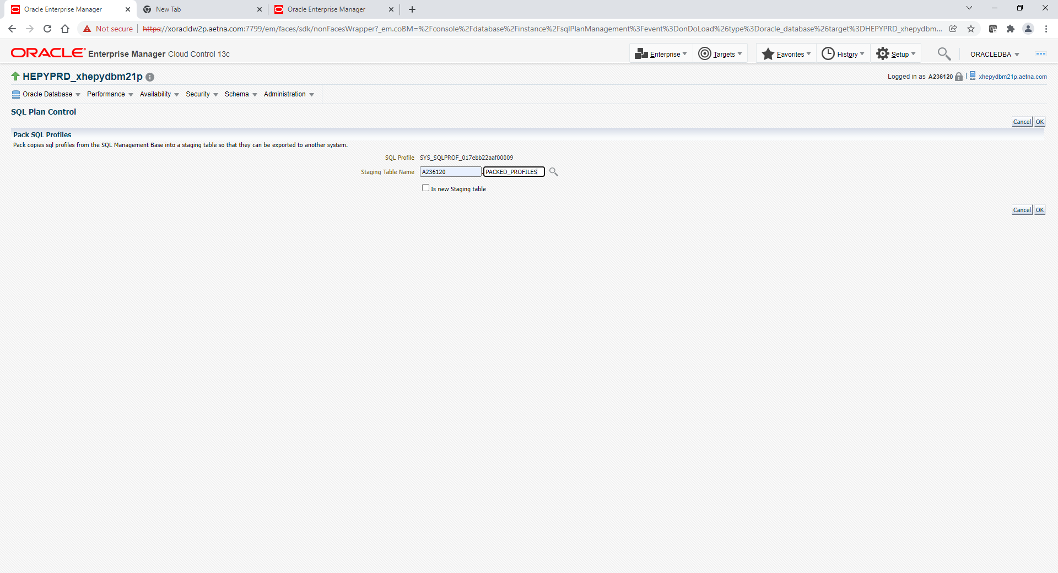

Specify schema/table. If you already have table below you may want to truncate prior to that. If not OEM will create table for you under your schema account.

TRUNCATE TABLE <A/N oracle account>.PACKED_PROFILES;

Click OK

|  |
| --- |
| **Information** |

Profile packed successfully.

5. Following step only applicable if you moving this SQL profile from one database to another.

Basically we need to export table that was populated and scp to different server where you would import.

cd /oraexport/u01/datapump

expdp <A/N oracle account>./xxx DIRECTORY=DATA_PUMP_DIR DUMPFILE=packed_profiles_XYZ.dmp TABLEs=A236120.PACKED_PROFILES

scp /oraexport/u01/datapump/packed_profiles_XYZ.dmp ServerXXX:/oraexport/u01/datapump/packed_profiles_XYZ.dmp

Login to ServerXXX

cd /oraexport/u01/datapump

##drop this table if exist or truncate

truncate table <A/N oracle account>.PACKED_PROFILES;

impdp <A/N oracle account>./xxx dumpfile=packed_profiles_XYZ.dmp logfile=packed_profiles_XYZ.log TABLE_EXISTS_ACTION=REPLACE

6. Unpack profiles

## Unpack the profiles

Go to OEM select particular database: HEPYPRD

Log under your A/N oracle account

1) Go to Performance->SQL->SQL Plan Control

2) Click the “Unpack” button on the right side of the screen

3) Enter A-ID for the schema and PACKED_PROFILES for the table name or whatever table name you have. Enter % for the category.

4) Click OK.